**Hands on 6**

**Bhuvanesh P – MM19B027**

1. Al – (111)

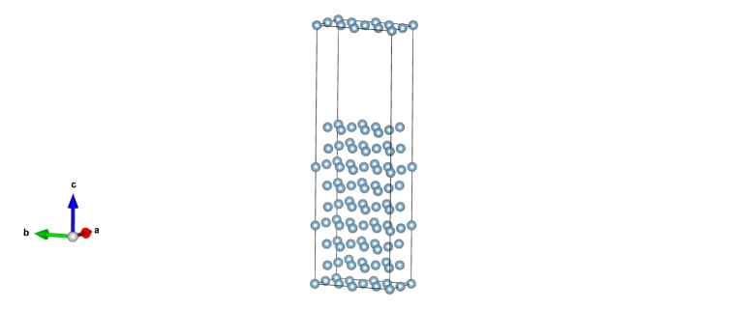

New structure

1.0

5.7134227753 0.0000000000 0.0000000000

0.0000000000 9.8959388733 0.0000000000

0.0000000000 0.0000000000 30.9924545288

Al

72

Cartesian

0.000000000 0.000000000 0.000000000

0.000000000 0.000000000 6.997485051

0.000000000 0.000000000 13.994970103

0.000000000 4.947969437 0.000000000

0.000000000 4.947969437 6.997485051

0.000000000 4.947969437 13.994970103

2.856711388 0.000000000 0.000000000

2.856711388 0.000000000 6.997485051

2.856711388 0.000000000 13.994970103

2.856711388 4.947969437 0.000000000

2.856711388 4.947969437 6.997485051

2.856711388 4.947969437 13.994970103

1.428355694 0.824661597 2.332494965

1.428355694 0.824661597 9.329979860

1.428355694 0.824661597 16.327464912

1.428355694 5.772630813 2.332494965

1.428355694 5.772630813 9.329979860

1.428355694 5.772630813 16.327464912

4.285067081 0.824661597 2.332494965

4.285067081 0.824661597 9.329979860

4.285067081 0.824661597 16.327464912

4.285067081 5.772630813 2.332494965

4.285067081 5.772630813 9.329979860

4.285067081 5.772630813 16.327464912

0.000000000 3.298646389 2.332494965

0.000000000 3.298646389 9.329979860

0.000000000 3.298646389 16.327464912

0.000000000 8.246616121 2.332494965

0.000000000 8.246616121 9.329979860

0.000000000 8.246616121 16.327464912

2.856711388 3.298646389 2.332494965

2.856711388 3.298646389 9.329979860

2.856711388 3.298646389 16.327464912

2.856711388 8.246616121 2.332494965

2.856711388 8.246616121 9.329979860

2.856711388 8.246616121 16.327464912

0.000000000 1.649323195 4.664989930

0.000000000 1.649323195 11.662475294

0.000000000 1.649323195 18.659959720

0.000000000 6.597292779 4.664989930

0.000000000 6.597292779 11.662475294

0.000000000 6.597292779 18.659959720

2.856711388 1.649323195 4.664989930

2.856711388 1.649323195 11.662475294

2.856711388 1.649323195 18.659959720

2.856711388 6.597292779 4.664989930

2.856711388 6.597292779 11.662475294

2.856711388 6.597292779 18.659959720

1.428355694 4.123307766 4.664989930

1.428355694 4.123307766 11.662475294

1.428355694 4.123307766 18.659959720

1.428355694 9.071276907 4.664989930

1.428355694 9.071276907 11.662475294

1.428355694 9.071276907 18.659959720

4.285067081 4.123307766 4.664989930

4.285067081 4.123307766 11.662475294

4.285067081 4.123307766 18.659959720

4.285067081 9.071276907 4.664989930

4.285067081 9.071276907 11.662475294

4.285067081 9.071276907 18.659959720

1.428355694 2.473984718 0.000000000

1.428355694 2.473984718 6.997485051

1.428355694 2.473984718 13.994970103

1.428355694 7.421954155 0.000000000

1.428355694 7.421954155 6.997485051

1.428355694 7.421954155 13.994970103

4.285067081 2.473984718 0.000000000

4.285067081 2.473984718 6.997485051

4.285067081 2.473984718 13.994970103

4.285067081 7.421954155 0.000000000

4.285067081 7.421954155 6.997485051

4.285067081 7.421954155 13.994970103



$γ_{surface}= \frac{1}{2A} \left(E_{Surface+bulk}- E_{bulk}\right)$

$$E_{Surface+bulk}= -347.92023682 eV$$

$E_{bulk}= -359.19444611$ eV

The lattice vectors is given by

a = 11.42685 Ao

b = 9.8959 Ao

c = 13.99497 Ao

The 111 surface is given by ab = 113.079 Angstrom square

$$γ_{surface}= \frac{1}{2(113.079)} \left(-347.92023682- -359.19444611\right)$$

$γ_{surface}=$ 0.049851 eV/A2

= 0.79216 J/m2